Experiment 9: Continuous Integration Pipeline Setup Using GitHub Actions

Aim
To set up a GitHub Actions Continuous Integration (CI) workflow, automate the build process, automate the test execution workflow from Experiment 8, validate model training scripts within CI, generate build/test reports, and document the complete CI pipeline.

Prerequisites & Tool Stack
- Completed Experiments 2, 4, 6, and 8 (mlops-iris-classifier repository pushed to GitHub, with a data pipeline, MLflow tracking, and a pytest test suite)
- A GitHub account with the repository hosted on GitHub
- GitHub Actions (included free with GitHub repositories; no separate installation)
- Basic YAML syntax familiarity

Theoretical Background
Continuous Integration (CI) is the practice of automatically building and testing every code change as soon as it is pushed or proposed (via a Pull Request), rather than relying on developers to manually run checks locally before merging. In an MLOps context, CI serves an expanded role beyond traditional software: it is the automated enforcement mechanism for every quality gate established in prior experiments — the data validation checks (Experiment 4), the unit and pipeline tests (Experiment 8), and, most distinctively, the model quality gate (also Experiment 8) that ensures a code or data change cannot be merged if it would silently degrade model performance below an acceptable threshold.
GitHub Actions implements CI through workflows: YAML files stored in .github/workflows/ that declare one or more jobs, each composed of a sequence of steps executed on a fresh, ephemeral virtual machine (a runner). Workflows are triggered by repository events — commonly push (a commit lands on a branch) and pull_request (a PR is opened or updated) — which is what enables the critical MLOps pattern of blocking a Pull Request from being merged until its CI workflow passes, via GitHub’s branch protection rules.
A well-designed ML CI workflow typically separates concerns into distinct jobs or stages: a build/lint stage (dependency installation, static code checks, ensuring the environment itself is reproducible), a test stage (running the full pytest suite from Experiment 8, including the model quality gate), and often a reporting stage (publishing coverage percentages, test result summaries, or even posting a comment on the PR with key metrics). Running these as isolated, declared steps — rather than one large opaque script — is what makes CI failures immediately diagnosable: a failed “lint” step tells a developer something different from a failed “model quality gate” step, without needing to dig through unstructured log output to figure out which category of problem occurred.
Caching is an important efficiency technique in ML CI specifically, because installing large ML libraries (scikit-learn, pandas, mlflow) from scratch on every single run can take several minutes; GitHub Actions’ actions/cache step persists the pip package cache between workflow runs (keyed by a hash of requirements.txt), meaningfully reducing CI turnaround time — a genuine practical concern in MLOps, since fast CI feedback loops directly affect how often developers are willing to commit small, incremental, easily-reviewable changes versus large, risky batches.
Build reports — JUnit XML test results (produced in Experiment 8) and coverage reports — are what transform a CI run from a simple pass/fail signal into an inspectable, historical record: GitHub Actions can render a JUnit XML summary directly in the workflow run’s UI (via a reporting action) and archive full logs/coverage HTML as downloadable artifacts, letting a reviewer see exactly which specific test failed and why, without needing to reproduce the failure locally.

Step-by-Step Implementation Procedure
Push practical 8 files to git hub:
cd mlops-iris-classifier
pwd
git status
git branch --show-current
git remote -v
git status
git add src/pipeline/validate.py pytest.ini
git commit -m "updating and adding practical 8 files"
git push origin main
git add tests/test_features.py tests/test_model_quali
ty.py tests/test_preprocess.py tests/test_training_pipeline.py tests/test_validate.py
git commit -m "adding the unit tests"
git push origin main
git status

Step 1: Directory Structure for the Workflow
code .
source .venv-mlflow/Scripts/activate
python --version
python -m pytest -v
ls
ls src/pipeline
ls tests
python -m pip install --force-reinstall scikit-learn==1.5.1
python -c "import sklearn; print(sklearn.__version__)"
python -m pytest -v
python -m pytest --cov=src --cov-report=term-missing
mkdir -p .github/workflows
touch .github/workflows/ci.yml create empty file
ls -la .github/workflows check if the file exists
code .github/workflows/ci.yml

Step 2: Write the CI Workflow YAML
name: MLOps CI Pipeline
on:
push:
branches: [main, develop]
pull_request:
branches: [main, develop]
permissions:
contents: read
jobs:
build-and-lint:
name: build-and-lint
runs-on: ubuntu-latest
steps:
- name: Checkout repository
uses: actions/checkout@v4
- name: Set up Python
uses: actions/setup-python@v5
with:
python-version: "3.11"
cache: pip
cache-dependency-path: requirements.txt
- name: Install dependencies
run: |
python -m pip install --upgrade pip
python -m pip install -r requirements.txt
python -m pip install flake8 pytest pytest-cov
- name: Compile Python files
run: python -m compileall -q src tests
- name: Lint source code
run: |
python -m flake8 src/ \
--max-line-length=100 \
--extend-ignore=E203 \
--statistics
test-suite:
name: test-suite
needs: build-and-lint
runs-on: ubuntu-latest
steps:
- name: Checkout repository
uses: actions/checkout@v4
- name: Set up Python
uses: actions/setup-python@v5
with:
python-version: "3.11"
cache: pip
cache-dependency-path: requirements.txt
- name: Install dependencies
run: |
python -m pip install --upgrade pip
python -m pip install -r requirements.txt
python -m pip install pytest pytest-cov
- name: Create data directories
run: mkdir -p data/raw data/processed
- name: Collect Iris data
run: |
python src/pipeline/collect.py \
--output data/raw/iris_raw.csv
- name: Preprocess Iris data
run: |
python src/pipeline/preprocess.py \
--input data/raw/iris_raw.csv \
--output data/processed/iris_preprocessed.csv
- name: Engineer features
run: |
python src/pipeline/features.py \
--input data/processed/iris_preprocessed.csv \
--output data/processed/iris_features.csv
- name: Run complete test suite
run: |
python -m pytest tests/ -v \
--cov=src \
--cov-report=term-missing \
--cov-report=xml:coverage.xml \
--junitxml=test-results.xml
- name: Upload test and coverage reports
if: always()
uses: actions/upload-artifact@v4
with:
name: test-and-coverage-reports
path: |
test-results.xml
coverage.xml
if-no-files-found: warn
model-quality-gate:
name: model-quality-gate
needs: test-suite
runs-on: ubuntu-latest
steps:
- name: Checkout repository
uses: actions/checkout@v4
- name: Set up Python
uses: actions/setup-python@v5
with:
python-version: "3.11"
- name: Install dependencies
run: |
python -m pip install --upgrade pip
python -m pip install -r requirements.txt
python -m pip install pytest
- name: Create data directories
run: mkdir -p data/raw data/processed
- name: Collect Iris data
run: |
python src/pipeline/collect.py \
--output data/raw/iris_raw.csv
- name: Preprocess Iris data
run: |
python src/pipeline/preprocess.py \
--input data/raw/iris_raw.csv \
--output data/processed/iris_preprocessed.csv
- name: Engineer features
run: |
python src/pipeline/features.py \
--input data/processed/iris_preprocessed.csv \
--output data/processed/iris_features.csv
- name: Validate model quality
run: python -m pytest tests/test_model_quality.py -v

What does each job do?
1. build-and-lint
Installs Python dependencies, compiles the Python source files, and checks code style with Flake8.
Runs first.
2. test-suite
Runs your Practical 8 pytest suite and generates test-results.xml and coverage.xml.
Runs only after the first job passes.
3. model-quality-gate
Runs your dedicated model quality test. It must be able to obtain or generate the model and test data it needs.
Runs only after the test suite passes.
The needs: statements define the execution order. If an upstream job fails, dependent jobs are skipped.

python -m pip install autopep8
python -m pip install flake8
python -m autopep8 --in-place --recursive --max-line-length=100 src
python -m flake8 src/ --max-line-length=100 --statistics

code src/generate_data.py Remove the unused import import pandas as pd
code src/pipeline/preprocess.py on line 41 edit the comment if exist: # Remove collection timestamp. The timestamp was useful as collection metadata, but it isn't a model feature here.
Replace with: # Remove the collection timestamp because it isn't a model feature.
git status
git add src/
git commit -m "Fix linting issues and format source code"
git push origin main

Step 3: Commit and Push the CI Workflow
git add .github/workflows/ci.yml requirements.txt
git commit -m "ci: add GitHub Actions workflow"
git push origin main
Run and inspect CI on GitHub, Observe the workflow
Open your repository on GitHub.
1. Open Actions
Select the Actions tab in your repository. Look for MLOps CI Pipeline.
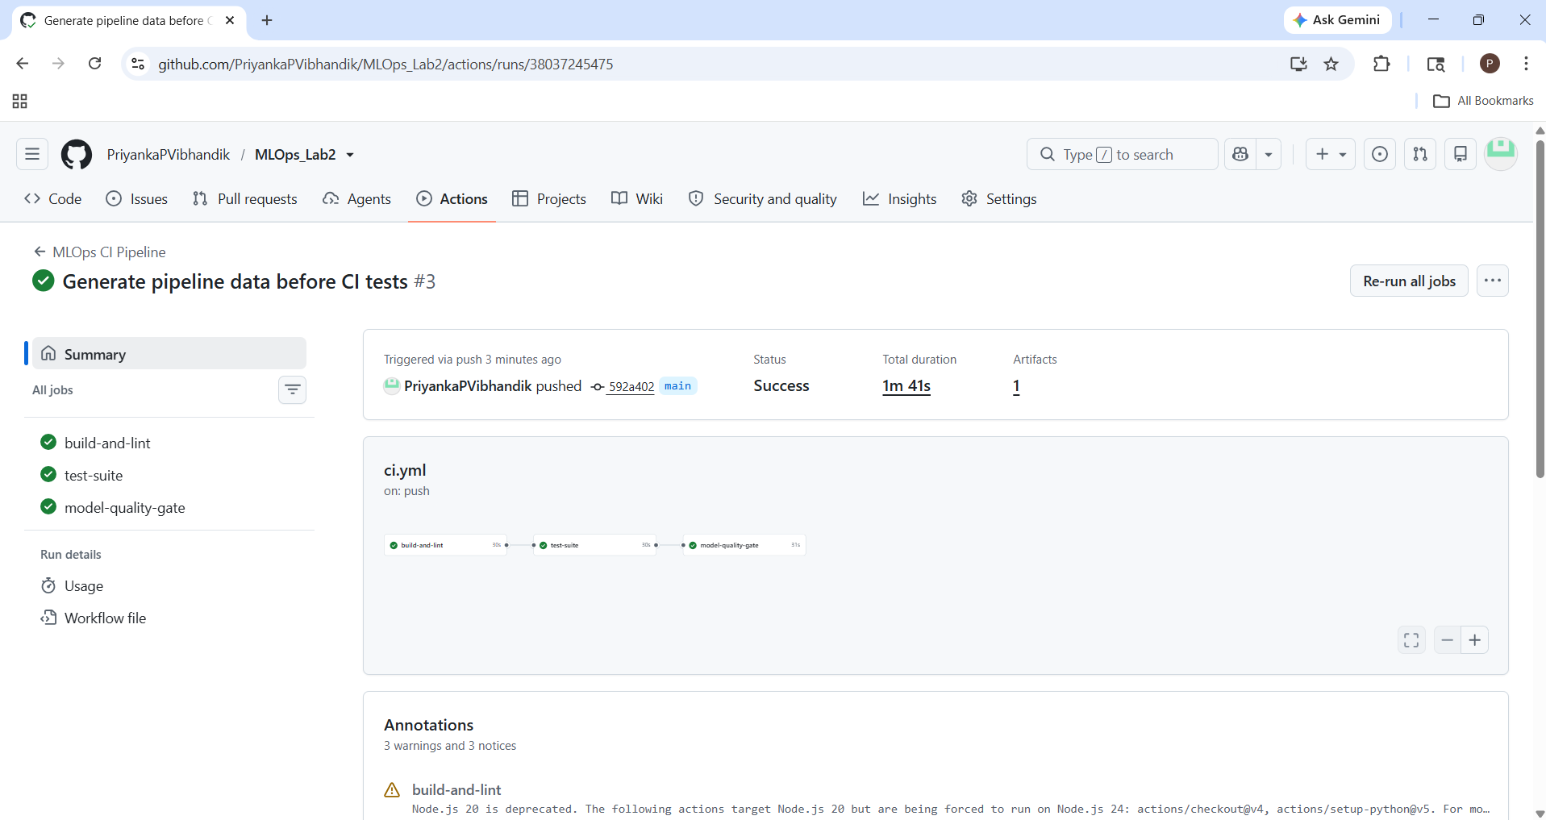
2. Open the workflow run
Inspect the build-and-lint, test-suite, and model-quality-gate jobs. Open a failed step to read its error logs.
3. Download reports
When the test job uploads its artifacts, open the completed run's summary and download test-and-coverage-reports.
To download report, look for Artifacts. It is usually near the bottom of the run summary, below the jobs and other summary information.
Click test-and-coverage-reports to download the ZIP file. It contains 2 files,
You should see these files:
test-results.xml
Contains test results, including passed tests, failures, and errors.
coverage.xml
Contains code coverage information about which parts of your source code were exercised by tests.

Verify that CI runs on a pull request
After your first successful run, create a feature branch:
git checkout -b feature/ci-verification-test
Add a harmless comment to README.md #Updated, then run:
git add README.md
git commit -m "test: verify CI workflow"
git push -u origin feature/ci-verification-test

On GitHub, create a pull request from feature/ci-verification-test into main.
The pull_request trigger should start the CI workflow. Confirm that the checks appear on the pull request.
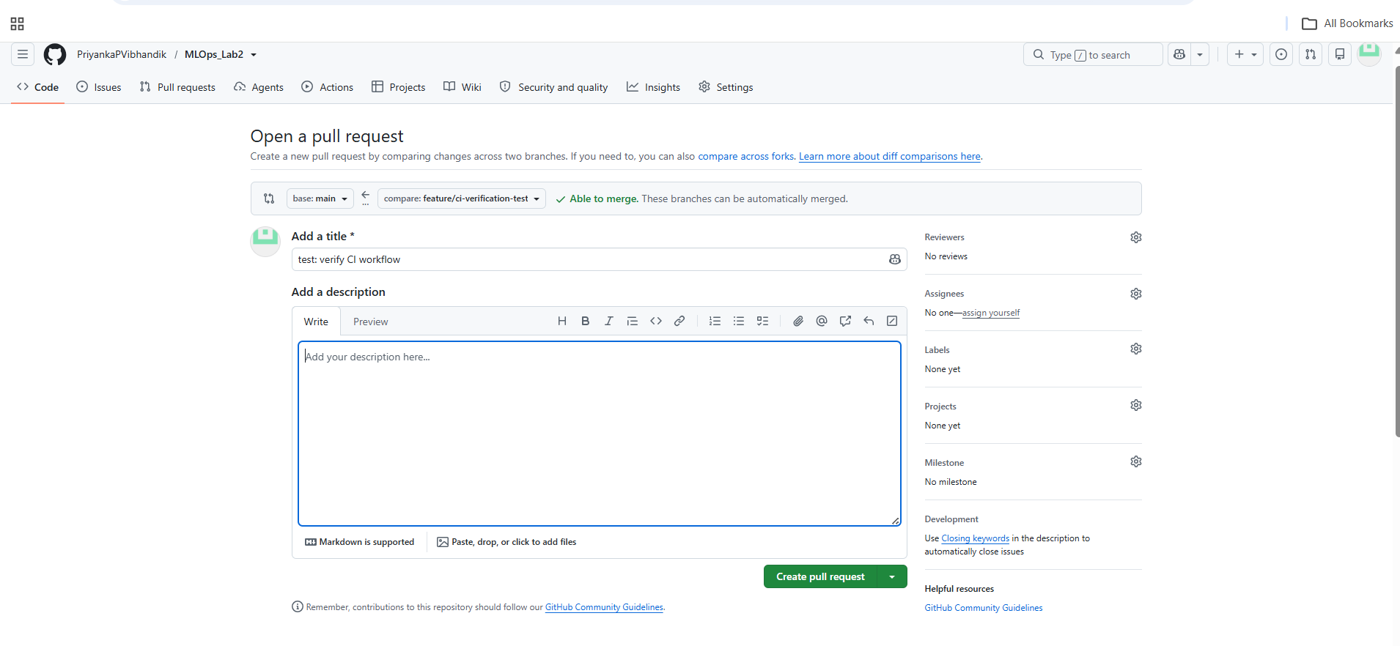
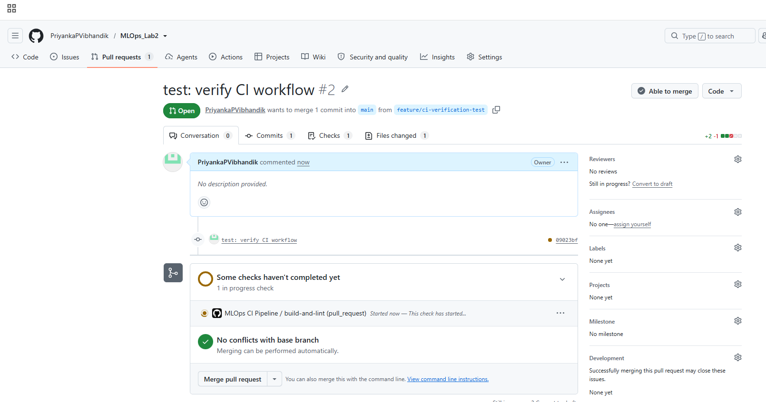
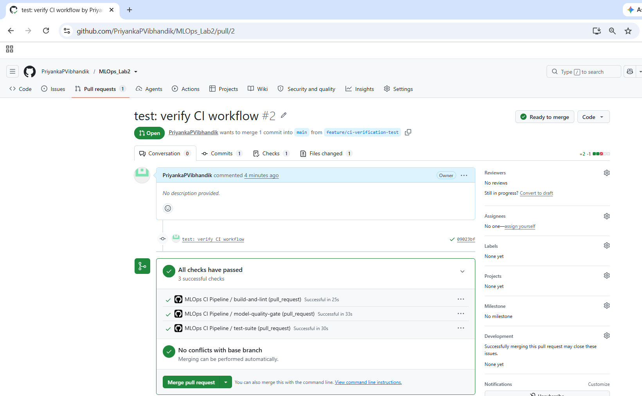
Merge pull request then confirm merge.
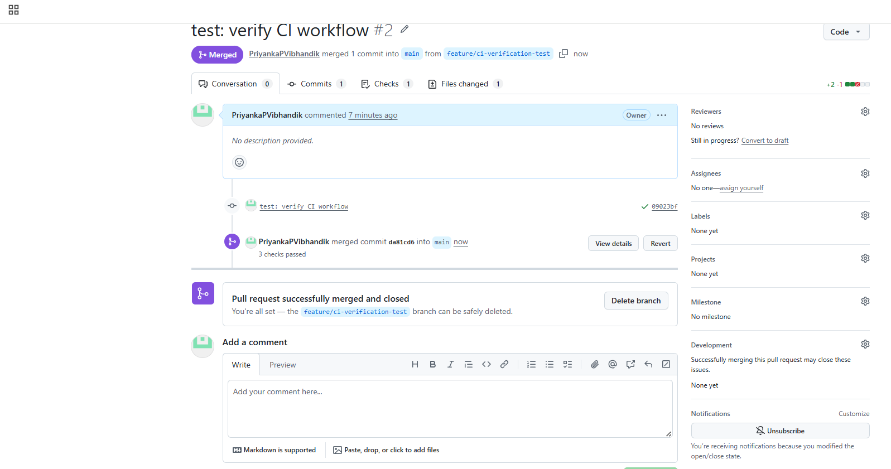

Step 4: Configure Branch Protection to Enforce the CI Gate
On GitHub, open Settings → Rules → Rulesets (or the available branch protection settings for your repository) and configure a rule targeting main.
Step 1: Create the ruleset
- Click the green New ruleset button.
- Select New branch ruleset.
- GitHub will open a configuration page. Give the ruleset a name such as Protect main - CI checks.
Step 2: Set the ruleset details
Fill in the fields as follows:
Ruleset name: Protect main - CI checks
Enforcement status:mActive
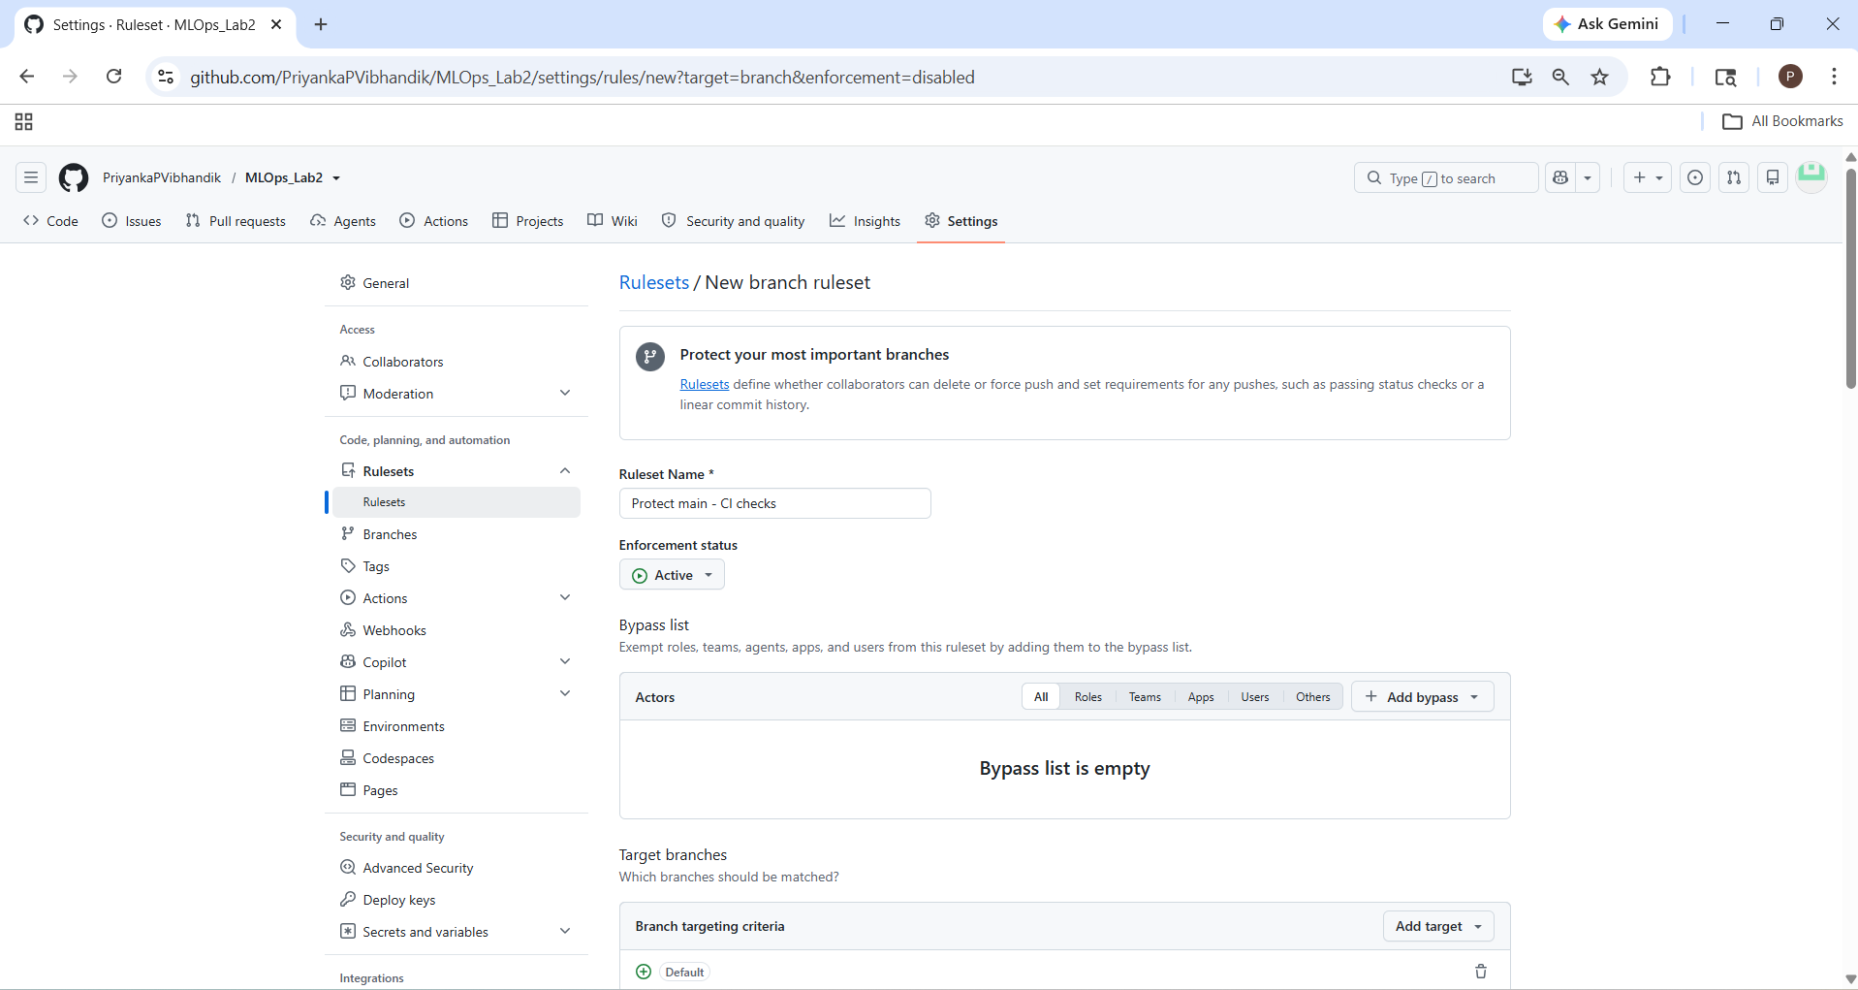
Target branches: Add a target → select Include default branch if offered, or add a branch-name pattern matching main.
Make sure the rule targets main, not every branch in your repository.
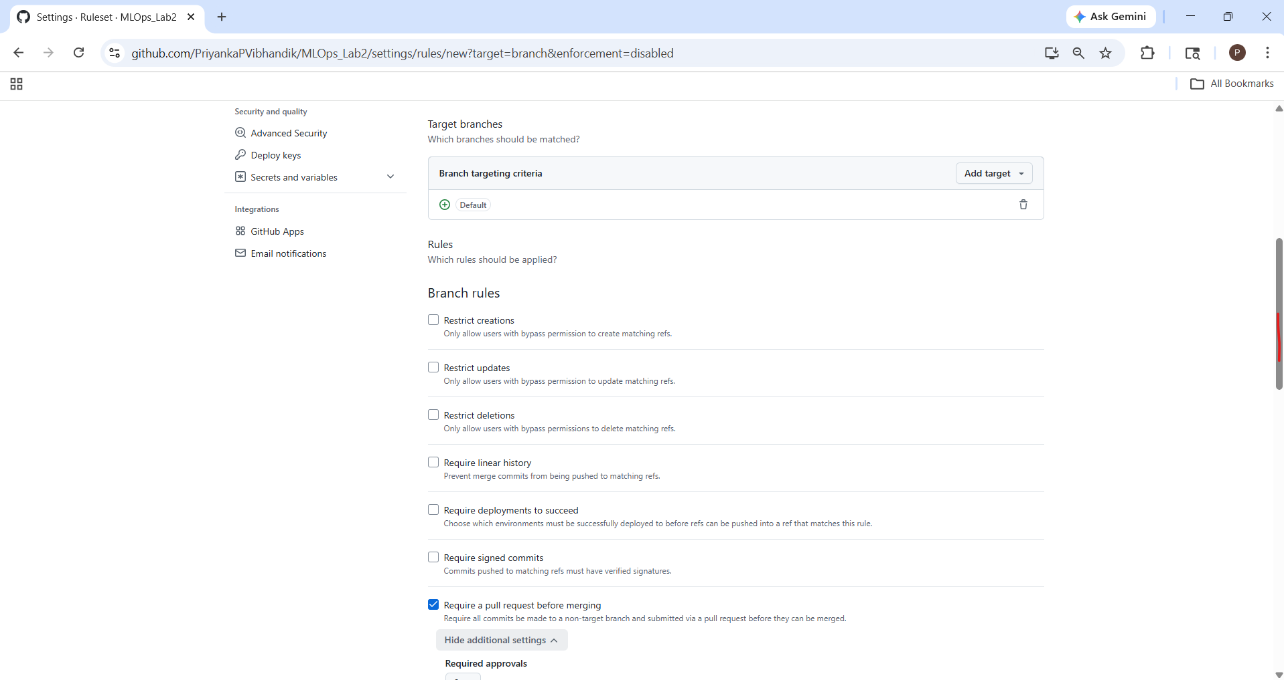
Step 3: Enable the required status checks
Scroll down to the Branch Rules section.
- Check Require a pull request before merging
- Check Require status checks to pass
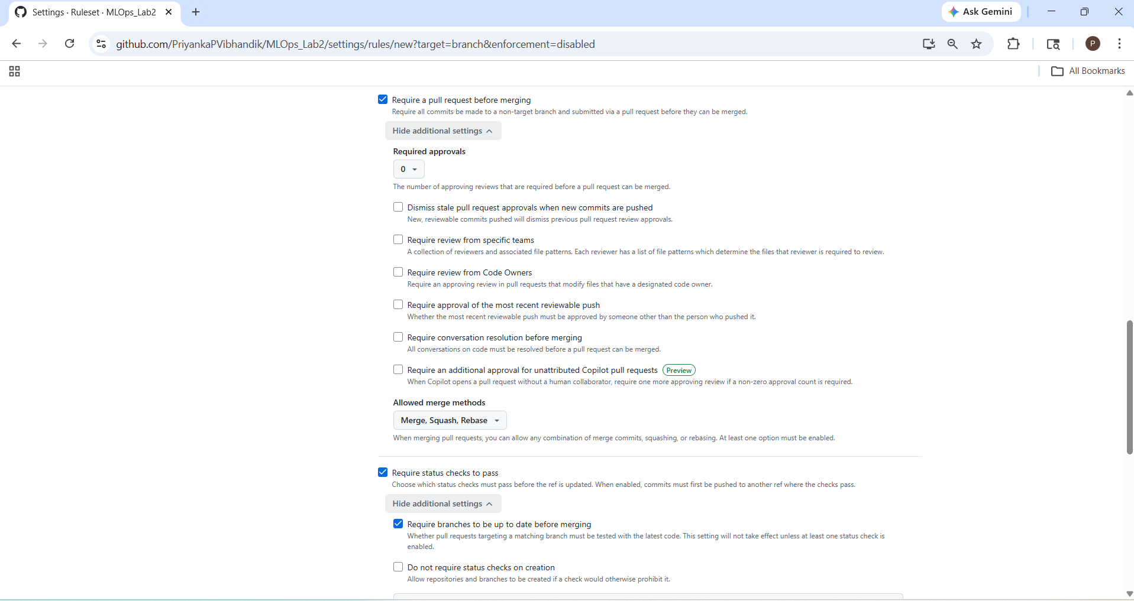
- Configure the status checks. After enabling Require status checks to pass:
- Find the field to add required status checks.
- Search for and select build-and-lint.
- Repeat for test-suite and model-quality-gate.
- If available, enable Require branches to be up to date before merging.
- If available, enable Require branches to be up to date before merging.
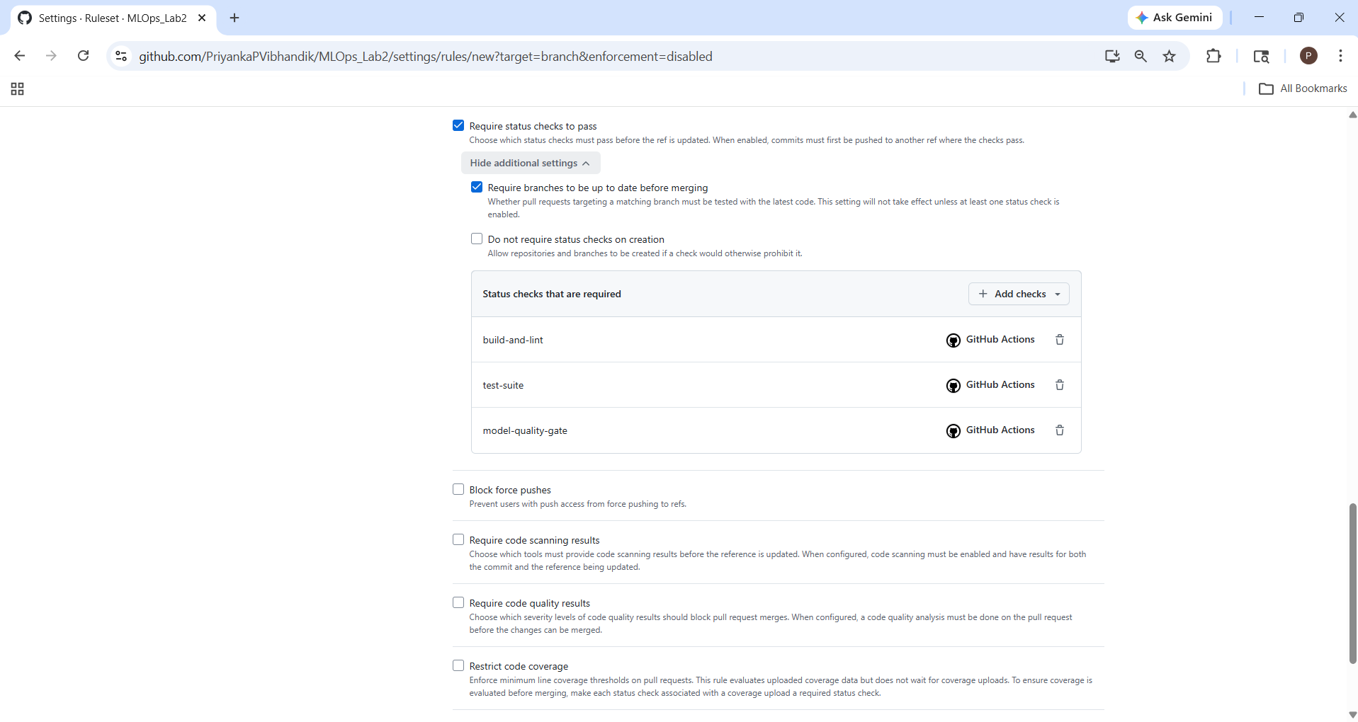
Choose the actual check names GitHub displays. They may include workflow context or a slightly different label.
Before saving
Confirm these settings:
- Ruleset: Active
- Target branch: main
- Require a pull request before merging: Enabled
- Require status checks to pass: Enabled
- Required checks: All three CI jobs
Then click Create ruleset at the bottom.
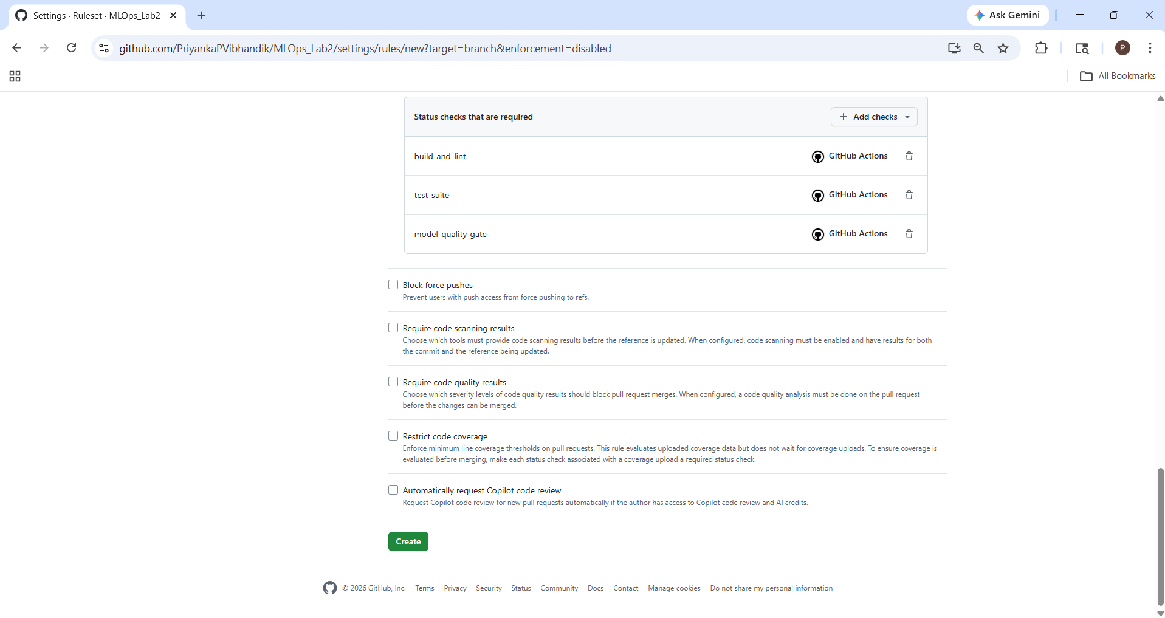
On clicking create, it might ask you for your git hub account password.
Step 4: Save the ruleset
Scroll to the bottom and click Create ruleset (or the equivalent save button shown on your page).
After saving, check that the ruleset appears in the list with its enforcement status set to Active.
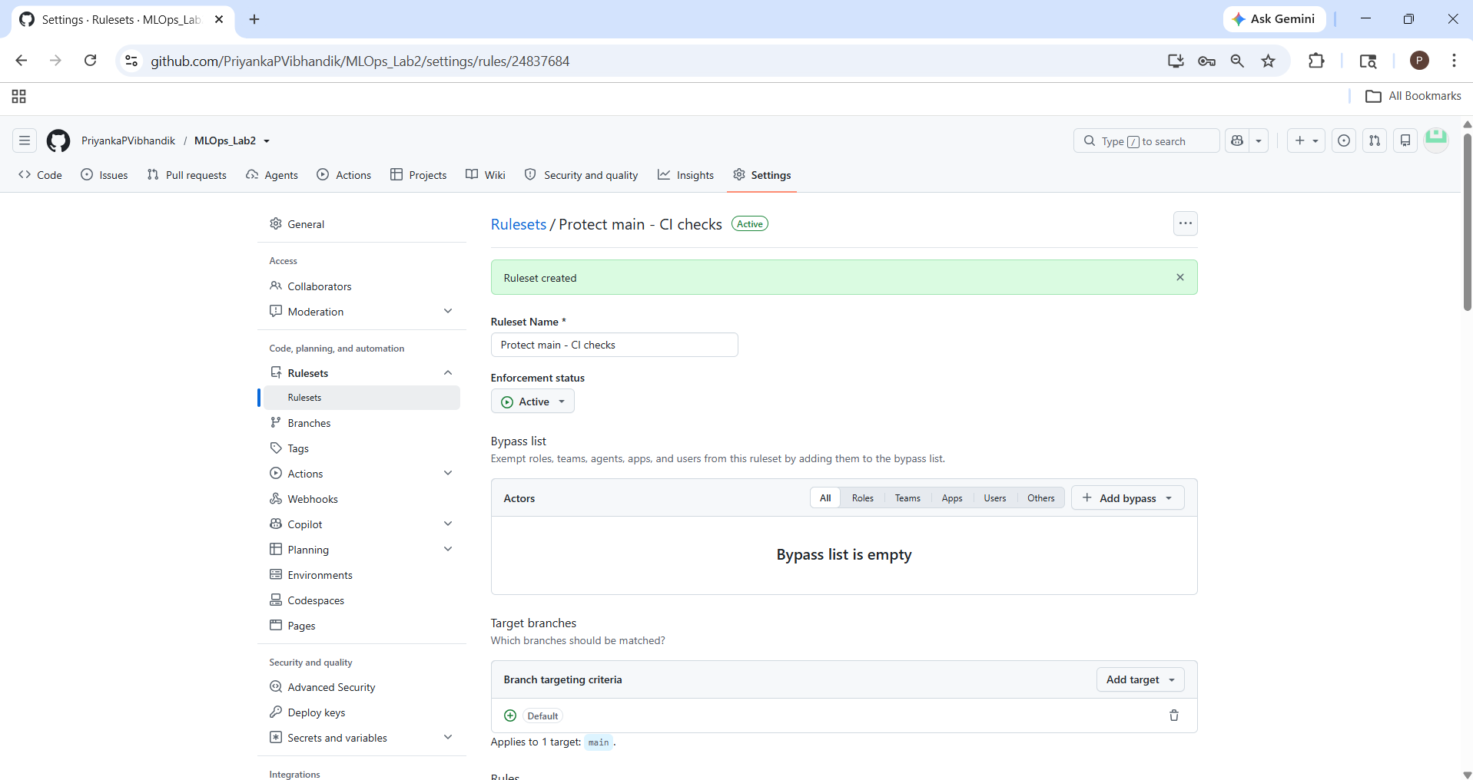

Step 5: Trigger and Observe the Workflow , Simulate a CI Failure (Model Regression)
Demonstrate a model-quality failure safely
You will temporarily change the accuracy threshold on a separate feature branch to demonstrate that CI catches a model-quality regression.
Do not make this change on main.
Open Git Bash
Go to your project directory: cd mlops-iris-classifier which you are already in.
git status
git branch
If your working tree is clean, create a separate branch from the updated main:
git checkout main
git pull origin main
git checkout -b feature/simulate-regression
if the tree is not clean:
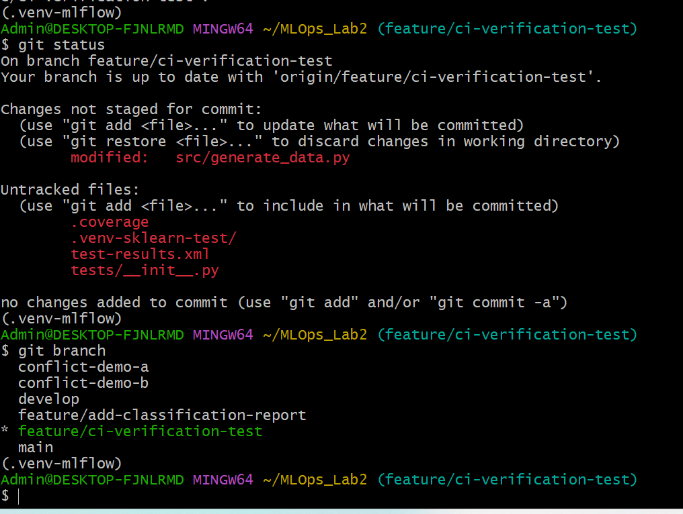
currently on feature/ci-verification-test, and the following items need attention:
- src/generate_data.py — modified tracked file; preserve your changes.
- .coverage, test-results.xml — generated reports; keep them out of Git.
- .venv-sklearn-test/ — virtual environment; do not commit it.
- tests/__init__.py — untracked file; preserve it for now rather than deleting it.

Safely save your current changes
In your existing Git Bash terminal,
git stash push -u -m "Save local changes before model quality test" -- src/generate_data.py .coverage test-results.xml tests/__init__.py
This saves the specified changes and untracked files in a stash without including the large virtual environment directory.
Now check:
git status
The listed modified file and selected untracked files should disappear from the working-tree status. The .venv-sklearn-test/ directory may still appear; that is okay.
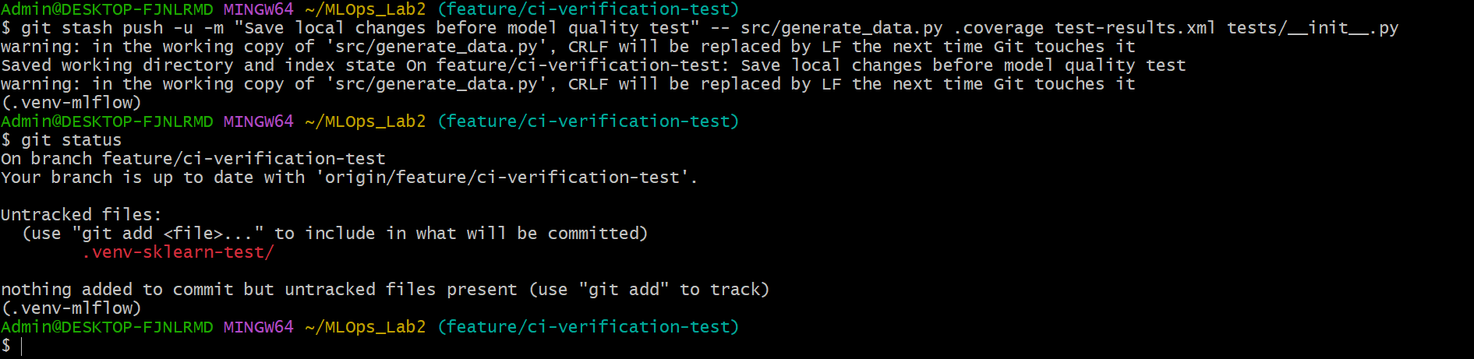
Switch to main and create the temporary branch
In the same Git Bash terminal, run these commands one at a time:
1. Switch to main:
git checkout main
2. Get the latest changes from GitHub:
git pull origin main
3. Create a separate branch for the model-quality failure demonstration:
git checkout -b feature/simulate-regression
4. Confirm your branch:
git branch
The asterisk (*) should appear beside:
feature/simulate-regression
This keeps the experiment separate from main, so your main branch remains unchanged.
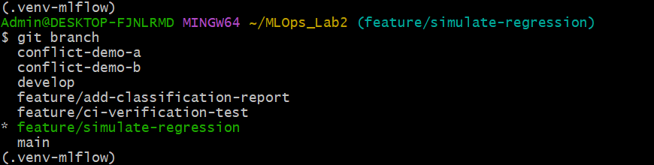
Temporarily raise the model accuracy threshold
Do not switch to main or merge this experiment.
- Open your project in VS Code.
- code tests/test_model_quality.py
- Find the line that defines the minimum acceptable accuracy. It should look similar to:
MIN_ACCEPTABLE_ACCURACY = 0.90
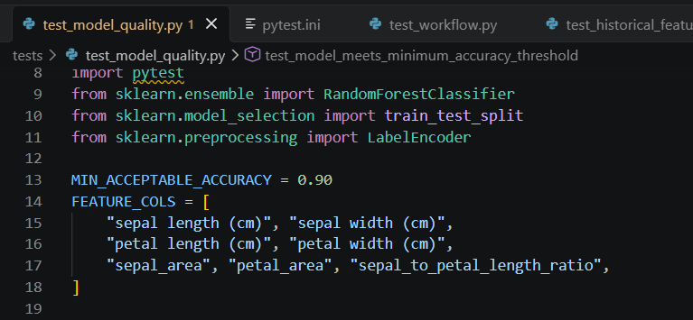
4. Change it to:
MIN_ACCEPTABLE_ACCURACY = 0.999
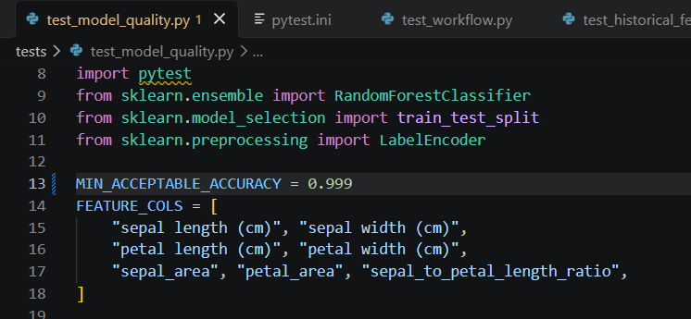
5. Save the file with Ctrl + S.
This deliberately sets a very high threshold so the model-quality test should fail if its measured accuracy is below 99.9%.
Before committing, verify the change
Run this in Git Bash:
git diff -- tests/test_model_quality.py
You should see the threshold changing from 0.90 to 0.999.
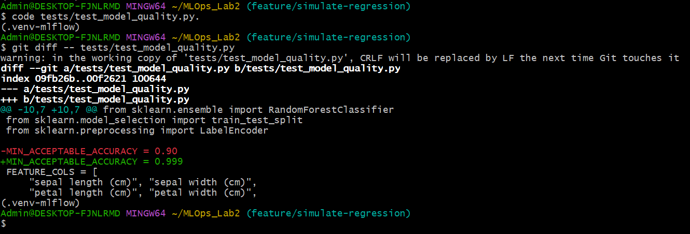
Commit and push the test branch
Run these commands in Git Bash, one at a time.
1. Stage the modified test file
git add tests/test_model_quality.py
2. Commit the change
git commit -m "test: simulate model quality failure"
3. Push your branch to GitHub
git push -u origin feature/simulate-regression
Create the demonstration pull request
On GitHub:
- Open your repository:
- Click Compare & pull request if GitHub displays that suggestion, or open Pull requests → New pull request.
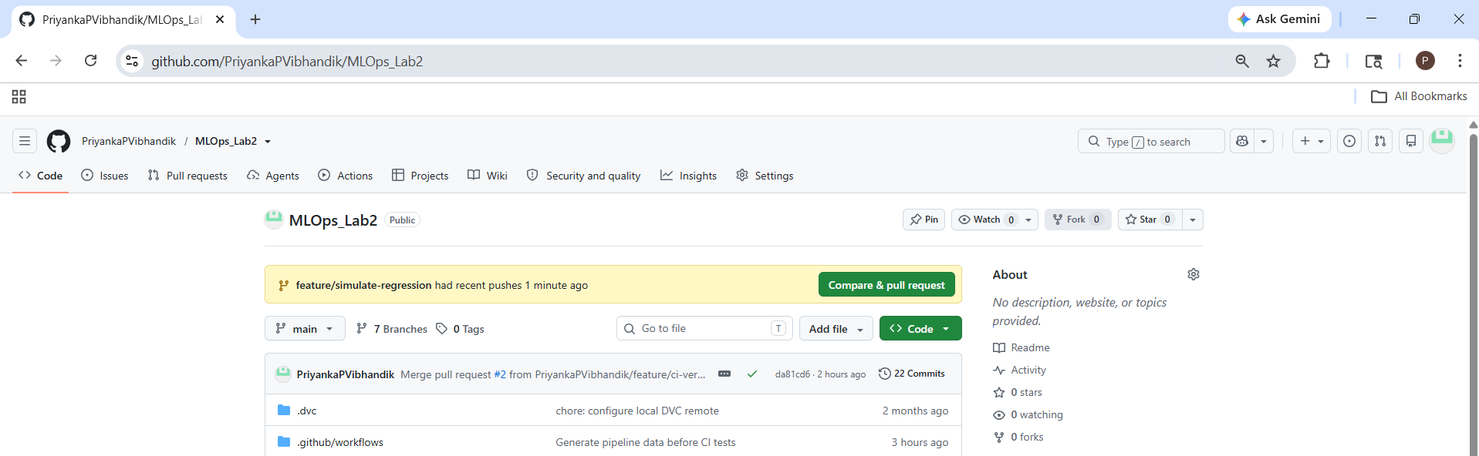
- Set the branches:
Base: main
Compare: feature/simulate-regression
- Use a title such as Test: Simulate model quality failure.
- Click Create pull request.
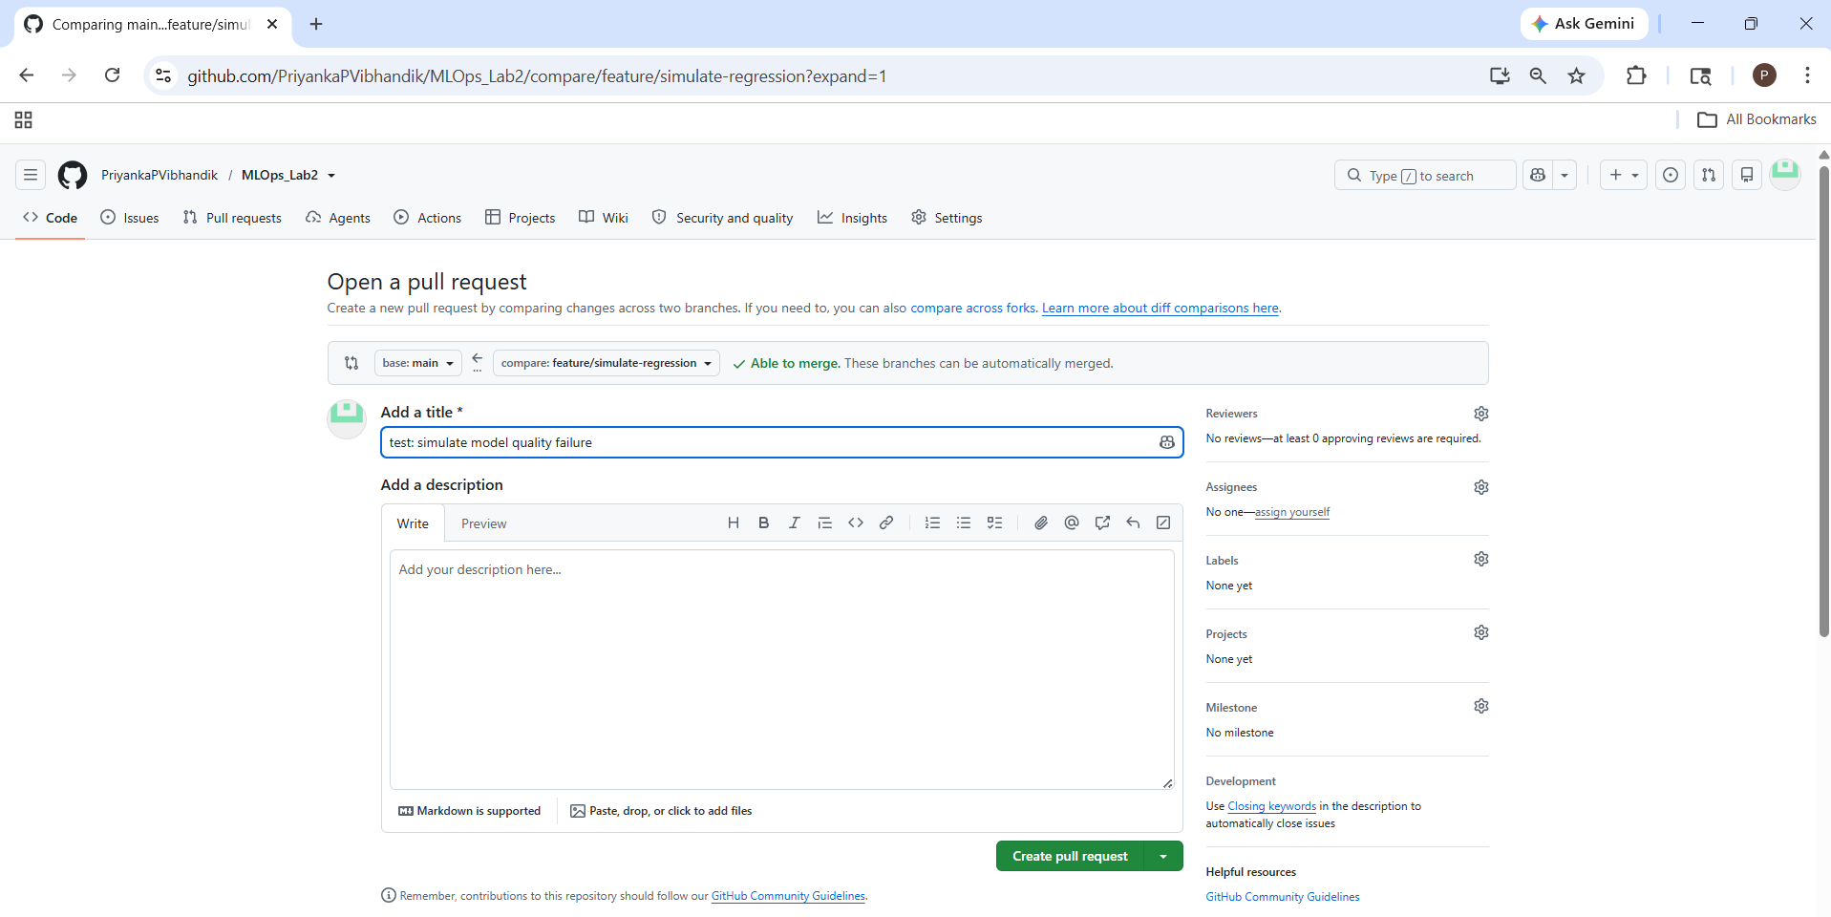
Your CI workflow should start automatically. Because the threshold is deliberately high, the model-quality-gate is expected to fail if the measured model accuracy is below 0.999.
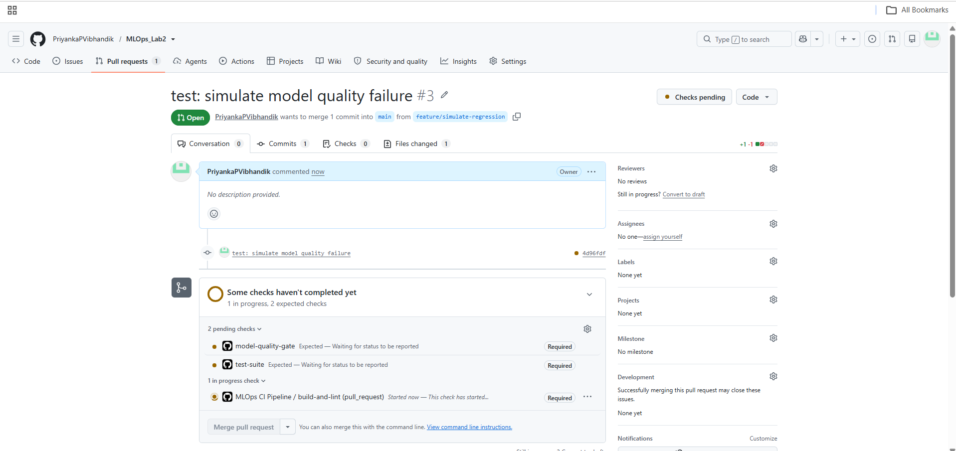
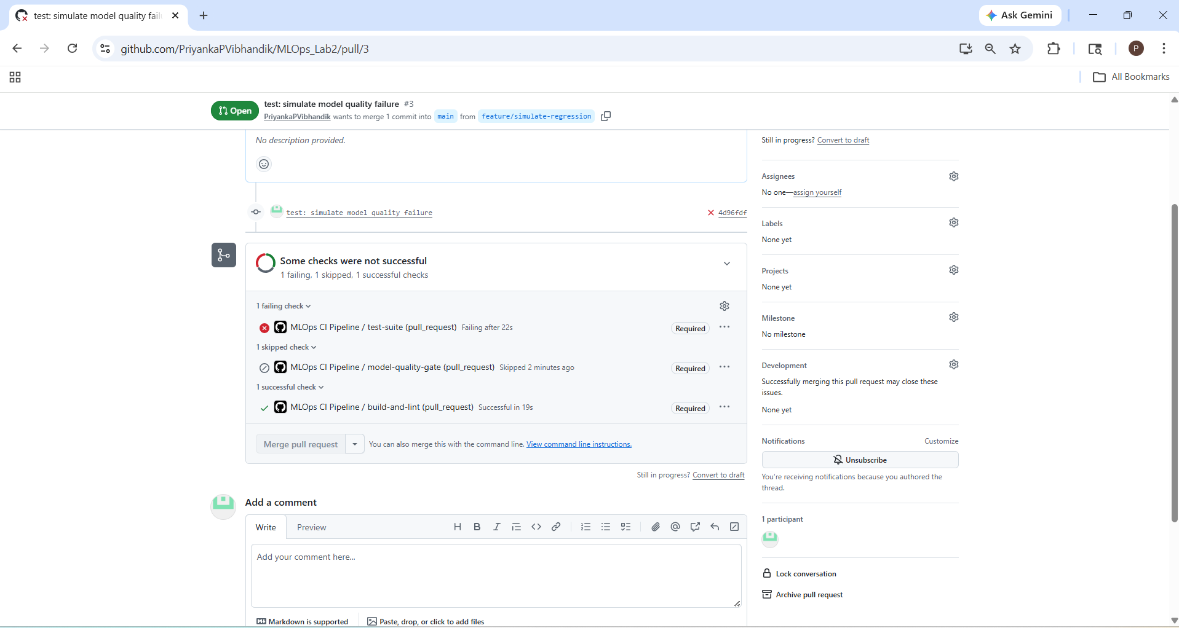
Inspect the failure
- Open your demonstration pull request on GitHub.
- Click Details beside the failed test-suite check.
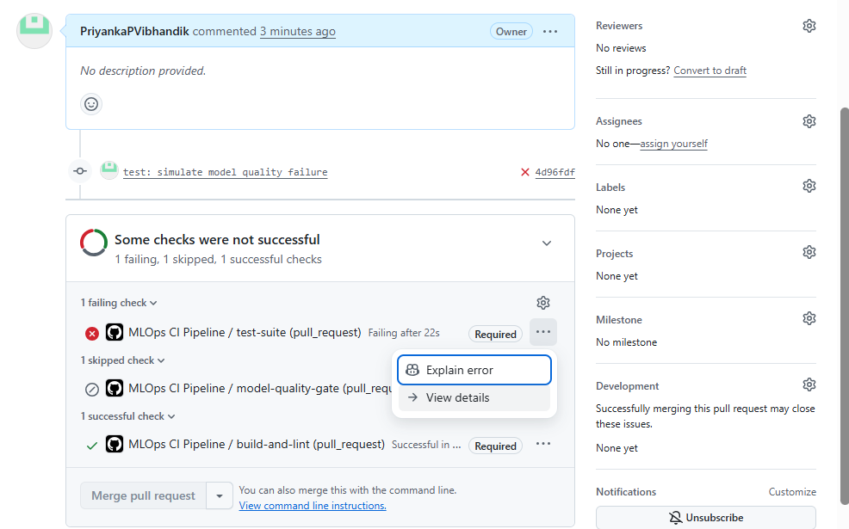
- Open the Run complete test suite step.
- Scroll to the bottom and find the failure details, especially the lines containing FAILED, AssertionError, or assert.
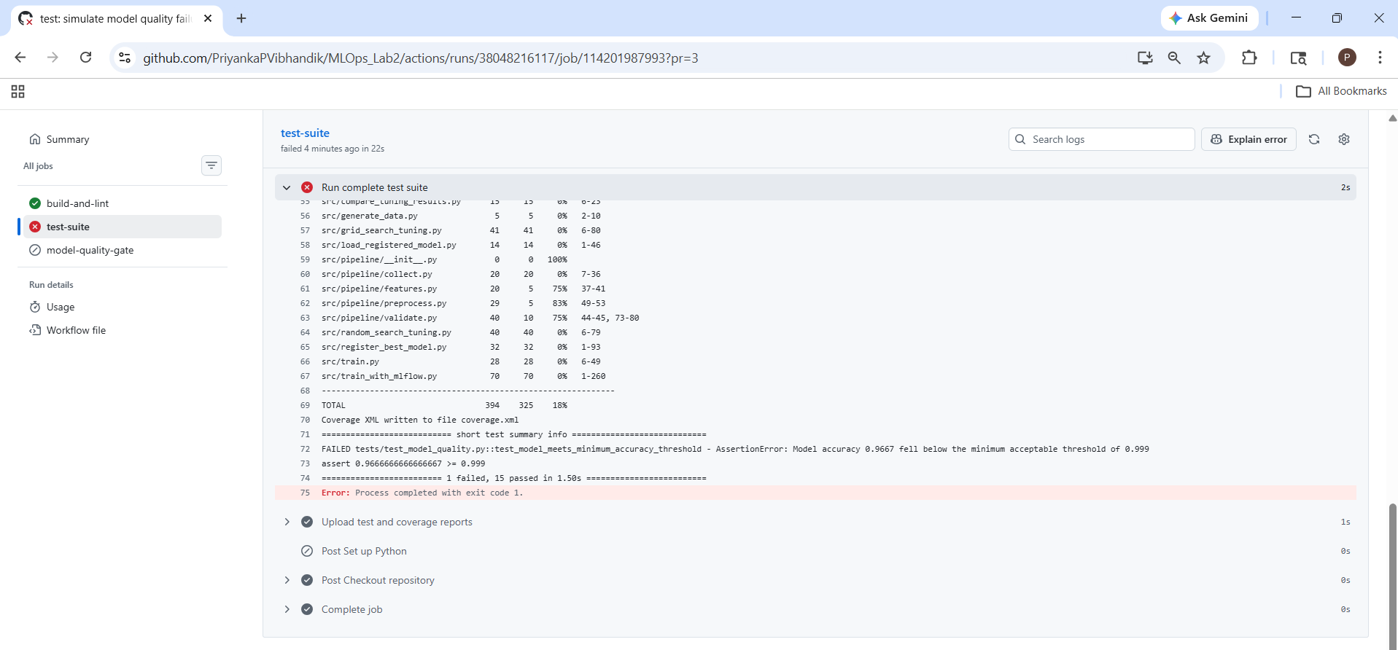
Why did the test fail?
Your original minimum accuracy threshold was 0.90 (90%). You temporarily raised it to 0.999 (99.9%).
The actual accuracy was 0.9667, or approximately 96.67%.
Metric | Value
Actual model accuracy | 96.67%
Required accuracy | 99.90%
Result | Failed
The error confirms this:
AssertionError: Model accuracy 0.9667 fell below
the minimum acceptable threshold of 0.999
The other 15 tests passed. This demonstrates that the CI workflow detects a model-quality regression and returns a failed status.

What should you do now?
1: Do not merge the feature/simulate-regression pull request. The failing check should prevent the merge under your ruleset.
2: Close the demonstration pull request without merging it. If GitHub offers Close pull request, use that option.
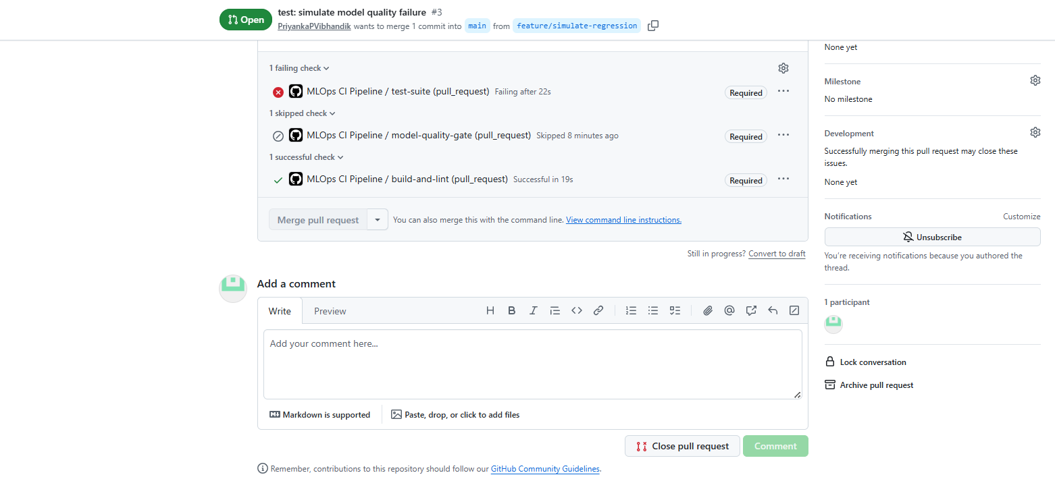
3: Restore your repository to its normal state by returning to main. Do not apply the temporary threshold change to main.
Delete the branch
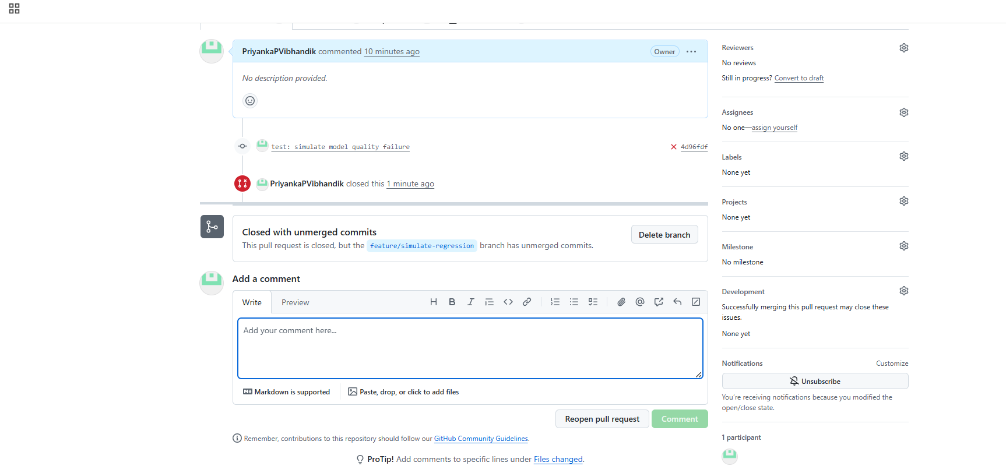
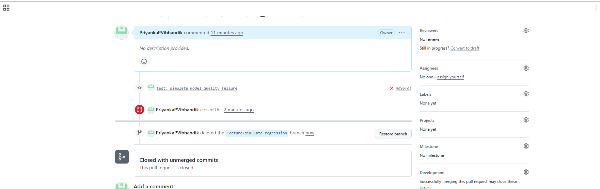
switch back to main
In Git Bash, run:
git diff -- tests/test_model_quality.py
You should see the temporary change from 0.90 to 0.999.
Step 2: Restore the test file
Since this branch was only for the failure demonstration and you don't need to keep that change, run:
git restore tests/test_model_quality.py
This restores the file to the version committed on your current branch. It does not affect your other files or your stash.
Step 3: Switch to main
Now run:
git switch main
Then verify the threshold:
grep "MIN_ACCEPTABLE_ACCURACY" tests/test_model_quality.py
Expected output:
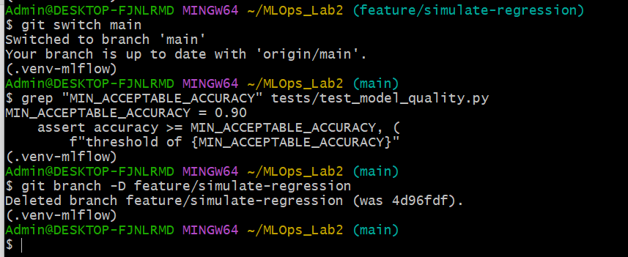
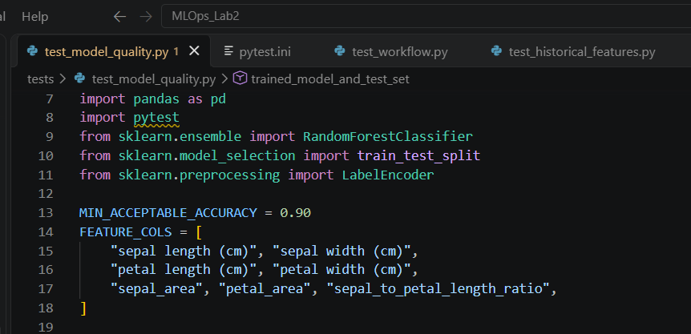
Step 4: Delete the local branch
Once you are safely on main, run:
git branch -D feature/simulate-regression

Step 6: Document the CI Pipeline
Create docs/CI_PIPELINE.md describing each job (build-and-lint, test-suite, model-quality-gate), their dependency order (needs:), the branch protection rule configured, and the Step 7 regression-blocking demonstration as evidence the gate is functioning correctly.
touch docs/CI_PIPELINE.mdmd
code docs/CI_PIPELINE.md
paste the below information in the file.
CI Pipeline Documentation
1. Overview
This project uses GitHub Actions to implement a Continuous Integration (CI) pipeline for the MLOps Iris project. The workflow is defined in .github/workflows/ci.yml.
The pipeline automatically runs when code is pushed to the main or develop branches and when a pull request targets either of these branches.
The CI pipeline checks Python code quality, executes automated tests, generates test and coverage reports, and validates model accuracy against a predefined threshold.
2. CI Jobs
The workflow consists of three jobs.
2.1 Build and Lint
Job name: build-and-lint
Purpose: Verify that the Python source code compiles successfully and follows the configured linting standards.
Main steps:
- Check out the repository.
- Set up Python 3.11.
- Install project dependencies, Flake8, and testing tools.
- Compile the Python files in src and tests.
- Run Flake8 on the source code.
Success condition: Python compilation and linting complete without errors.
2.2 Test Suite
Job name: test-suite
Dependency: needs: build-and-lint
Purpose: Execute the automated tests to verify the correctness of the data-processing pipeline and related functionality.
Main steps:
- Check out the repository and set up Python 3.11.
- Install project dependencies and testing tools.
- Create the required data directories.
- Collect the Iris dataset.
- Preprocess the dataset.
- Engineer features.
- Execute the tests using pytest.
- Generate test results and code coverage reports.
- Upload the reports as a GitHub Actions artifact named test-and-coverage-reports.
The artifact contains test-results.xml and coverage.xml when both files are generated successfully.
Success condition: All tests pass.
2.3 Model Quality Gate
Job name: model-quality-gate
Dependency: needs: test-suite
Purpose: Verify that the model satisfies the minimum acceptable accuracy requirement.
Main steps:
- Check out the repository and set up Python 3.11.
- Install the required dependencies.
- Prepare the Iris dataset by running the collection, preprocessing, and feature-engineering stages.
- Execute tests/test_model_quality.py.
The normal minimum accuracy threshold is 0.90 (90%).
Success condition: The model-quality tests pass, including the minimum accuracy assertion.
3. Job Dependency Order
The jobs are configured with the following dependency sequence:
build-and-lint
|
v
test-suite
|
v
model-quality-gate
The dependency configuration uses the needs keyword:
- test-suite requires build-and-lint to succeed.
- model-quality-gate requires test-suite to succeed.
Consequently, a failure in an upstream job causes downstream jobs to be skipped by default unless the workflow explicitly overrides this behavior.
4. Branch Protection Ruleset
A GitHub branch ruleset named Protect main - CI checks was configured to protect the main branch.
The ruleset includes:
- Requiring changes to be submitted through a pull request.
- Requiring the configured CI status checks to pass before merging.
- Requiring branches to be up to date before merging, if enabled in the repository settings.
The required status checks selected in GitHub are:
- build-and-lint
- test-suite
- model-quality-gate
This configuration helps prevent changes from being merged into main when the required checks fail.
5. Pull Request Verification
A feature branch named feature/ci-verification-test was created, and a harmless README change was committed and pushed.
A pull request was opened from this branch into main. The pull_request trigger started the GitHub Actions workflow, and all three jobs completed successfully.
The pull request was subsequently merged after the checks passed. This verified that the CI workflow runs on pull requests as intended.
6. Model-Quality Regression Demonstration
To test the pipeline's ability to detect a model-quality regression, a temporary branch named feature/simulate-regression was created.
The threshold in tests/test_model_quality.py was temporarily changed from:
MIN_ACCEPTABLE_ACCURACY = 0.90
to:
MIN_ACCEPTABLE_ACCURACY = 0.999
A pull request was opened from the temporary branch into main.
Observed results
- Build and Lint: Passed.
- Test Suite: Failed.
- Model Quality Gate: Skipped because it depends on the successful completion of test-suite.
The test output reported an accuracy of approximately 0.9667 (96.67%), which was below the temporary threshold of 0.999 (99.9%). As a result, the assertion in test_model_meets_minimum_accuracy_threshold failed.
The complete test suite reported 15 passed tests and 1 failed test. The failure demonstrated that the CI workflow detects a model that does not satisfy the configured accuracy requirement.
The demonstration pull request was not merged. The temporary branch was deleted, and the normal accuracy threshold of 0.90 was verified on main.
Note: The regression was detected by the model-quality test within test-suite. The separate model-quality-gate job was skipped because of its configured dependency. Thus, the experiment demonstrated regression detection, but the dedicated model-quality job did not independently execute during this failure scenario.
7. Conclusion
The GitHub Actions CI pipeline automates code compilation, linting, testing, report generation, and model-quality validation. Pull-request checks and branch protection provide safeguards for changes targeting main.
The successful normal pipeline run and the deliberately introduced regression provide evidence that the workflow executes correctly and detects a model-quality threshold violation.

Your documentation commit was created locally (6900ba2). The push was rejected, but the commit is still on your local main branch. We can preserve it and submit it through a pull request.
Step 1: Create a documentation branch
In Git Bash, run:
git switch -c docs/ci-pipeline-documentation
Your existing commit will stay on this new branch.
Step 2: Push the branch to GitHub
git push -u origin docs/ci-pipeline-documentation
Step 3: Create a pull request
Open your repository: on github
- Go to Pull requests.
- Click New pull request.
- Set base to main.
- Set compare to docs/ci-pipeline-documentation.
- Use the title docs: document CI pipeline and regression test.
- Click Create pull request.
Step 4: Wait for CI checks
Your workflow should run automatically. Wait for these three checks to pass:
- build-and-lint
- test-suite
- model-quality-gate
Once they pass, click Merge pull request and confirm the merge.
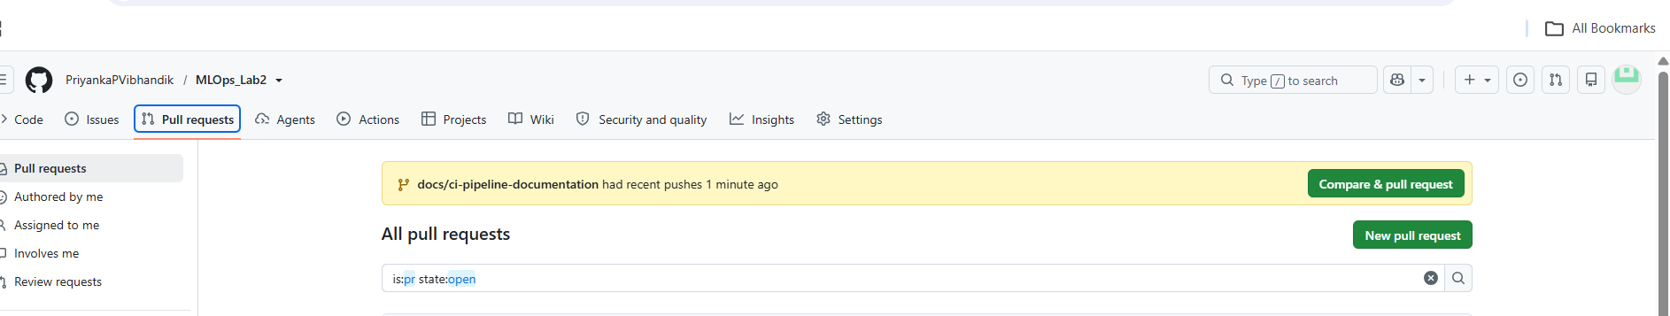
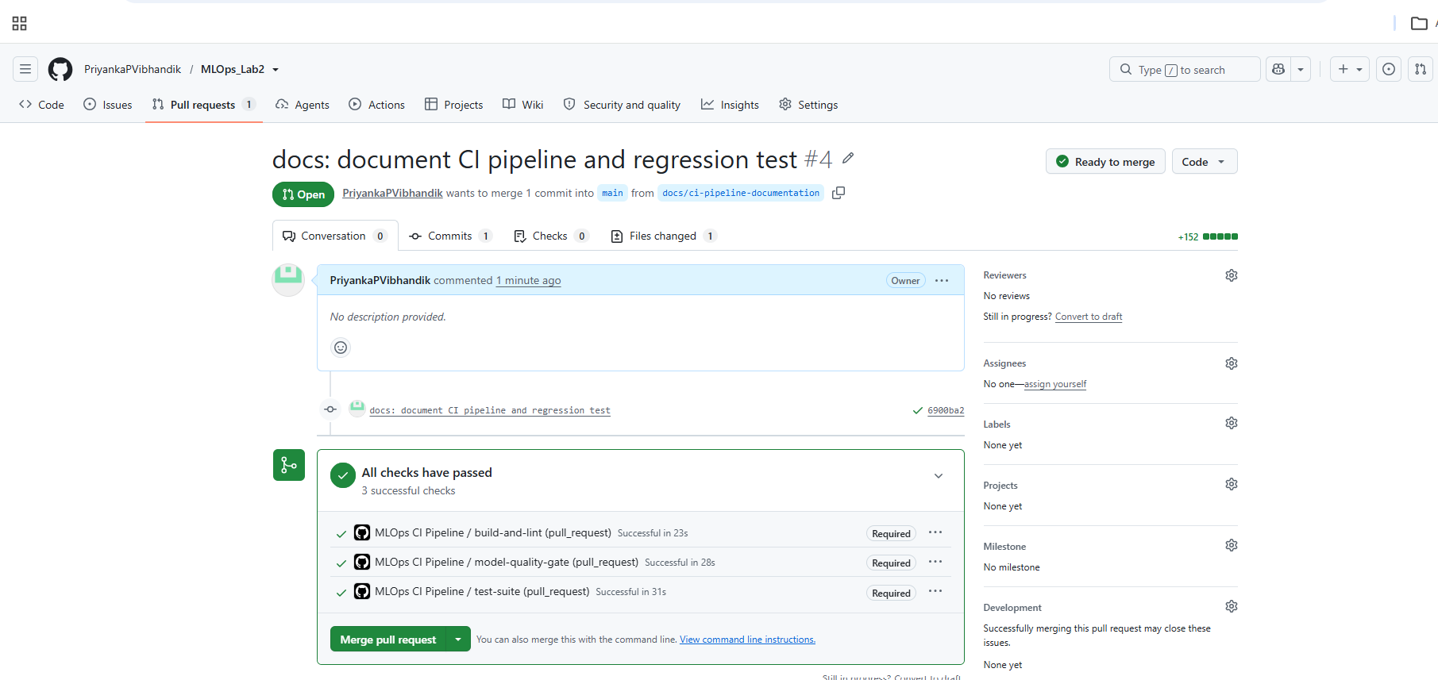
Merge and confirm
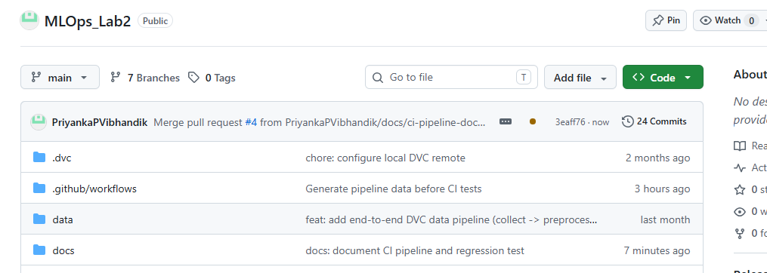

Verification & Execution Steps
- After pushing .github/workflows/ci.yml, the “Actions” tab on the GitHub repository shows a new workflow run triggered automatically, with three jobs listed: build-and-lint, test-suite, model-quality-gate, executing in the declared dependency order (via needs:).
- Each job completes with a green checkmark on a clean push; expanding the test-suite job’s log shows the full pytest -v output with all tests listed as PASSED, matching Experiment 8’s expected output.
- The “Pytest Results” check (from dorny/test-reporter) appears as a separate annotated check on the PR, summarizing pass/fail counts without requiring the reviewer to open raw logs.
- The coverage-report and test-results artifacts are downloadable from the completed workflow run’s summary page.
- In Step 7, the PR’s “Checks” tab shows model-quality-gate failing with a red X, and GitHub’s PR merge button is disabled with the message “Required statuses must pass before merging,” confirming branch protection correctly enforces the quality gate.
- docs/CI_PIPELINE.md exists and accurately documents the pipeline structure and the Step 7 verification evidence.

Viva-Voce / Post-Lab Questions
Q1. Explain the purpose of the needs: keyword used across the three jobs in this workflow, and what would change in the CI pipeline’s behavior and cost if it were removed. Answer: The needs: keyword declares an explicit dependency between jobs, telling GitHub Actions that test-suite must wait for build-and-lint to succeed before starting, and model-quality-gate must wait for test-suite. This creates a fail-fast pipeline: if linting fails, the (more expensive, longer-running) test and model-quality jobs never execute at all, saving compute time and giving the developer faster, more targeted feedback about the actual category of problem. If needs: were removed, all three jobs would run in parallel by default; this would mean unit test failures and model quality checks would still execute (and consume runner time) even when the code doesn’t even pass basic linting — wasting CI minutes on runs that were destined to fail regardless, and potentially producing confusing simultaneous failure reports across unrelated concerns.
Q2. In Step 5, branch protection was configured to require all three status checks before allowing a merge to main. Explain, from an MLOps governance perspective, why this is considered more reliable than relying on developers to run pytest locally before pushing. Answer: Relying on local test execution is not enforceable — it depends entirely on individual developer discipline, and there is no guarantee every developer’s local environment (library versions, OS, cached data) exactly matches the environment the tests are actually meant to validate against, potentially masking environment-specific failures. Required branch-protected CI status checks make passing the full test and quality-gate suite a structural precondition for merging, enforced uniformly by GitHub itself regardless of who is contributing or what they may have forgotten to run locally — converting an informal best practice (“please test before you push”) into a technically guaranteed gate, which is precisely the kind of governance control that distinguishes a mature MLOps workflow from an ad hoc one.
Q3. Step 7 demonstrated the CI pipeline correctly blocking a PR when the model quality gate failed. Explain why this specific test — deliberately engineering a failure and confirming CI catches it — is itself an important verification step, rather than simply trusting that a passing pipeline means the gate ‘works.’ Answer: A pipeline that only ever shows green checkmarks does not, by itself, prove that its checks are actually capable of catching a real problem — the gate could be silently misconfigured (e.g., pointing at the wrong test file, using an inverted or always-true condition, or the job could be misconfigured with continue-on-error: true, meaning it reports success regardless of the actual test outcome) and a team would have no way of knowing until a genuinely bad model was merged and deployed to production, at which point the failure is far more costly to detect and remediate. Deliberately introducing a known-bad change and confirming the pipeline correctly turns red and blocks the merge is a form of testing the test infrastructure itself; it provides concrete, positive evidence that the quality gate is wired correctly and will actually protect the main branch when a genuine regression occurs in the future, rather than merely assuming it will based on the absence of past failures.

